**Exercise 1: Mocking and Stubbing**

CODE:

//External Api class

*public class* ExternalApi {  
  
 *public* String getData(){  
  
 *//get data from external api  
  
 return* "";  
 }  
}

//MyService Class

*public class* MyService {  
  
 *private* ExternalApi api;  
  
 MyService(ExternalApi api){  
 *this*.api = api;  
 }  
  
 *public* String fetchData(){  
  
 String data = api.getData();  
 *return* data;  
  
 }  
}

//Test Class  
*import* org.junit.*Test*;  
*import* org.mockito.Mockito;  
*import static* org.junit.Assert.assertEquals;  
*public class* MyServiceTest {  
 *@Test  
 public void* testExternalApi() {  
 ExternalApi mockApi = Mockito.mock(ExternalApi.*class*);  
 Mockito.when(mockApi.getData()).thenReturn("Mock Data");  
 MyService service = *new* MyService(mockApi);  
 String result = service.fetchData();  
 assertEquals("Mock Data", result);  
 }  
}

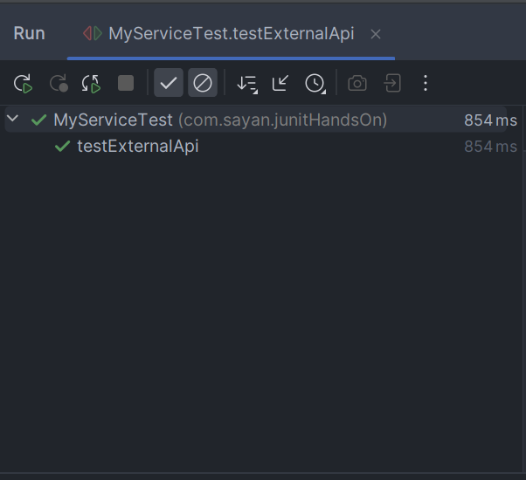OUTPUT:

**Exercise 2: Verifying Interactions**

CODE:

*import* org.junit.*Test*;  
*import* org.mockito.Mockito;  
  
*public class* MyServiceTest {  
   
 *@Test  
 public void* testVerifyInteraction() {  
 ExternalApi mockApi = Mockito.mock(ExternalApi.*class*);  
 MyService service = *new* MyService(mockApi);  
 service.fetchData();  
 Mockito.verify(mockApi).getData();  
 }  
}

OUTPUT:

